R1: Give an example of a diplomatic protocol.
From Wikipedia: Diplomatic protocol is commonly described as a set of international courtesy rules. These well-established and time-honored rules have made it easier for nations and people to live and work together. Part of protocol has always been the acknowledgment of the hierarchical standing of all present. Protocol rules are based on the principles of civility.

R2: Is there a difference between a host and an end system? ..
List types of end systems.
Is a web server an end system?

There is no difference. Throughout this text, the words “host” and “end system” are used interchangeably.

End systems include PCs, workstations, Web servers, mail servers, PDAs, Internet-connected game consoles, etc.

Yes, a web server is also an end system. A Web server falls into a category of end systems.

R6: What a some of the physical media that Ethernet can run over?
Today, Ethernet most commonly runs over twisted-pair copper wire. It also can run over fibers optic links

A Web cache—also called a proxy server—is a network entity that satisfies HTTP
requests on the behalf of an origin Web server. The Web cache has its own disk storage
and keeps copies of recently requested objects in this storage. As shown in Figure 2.11, a
user’s browser can be configured so that all of the user’s HTTP requests are first directed
to the Web cache. Once a browser is configured, each browser request for an object is
first directed to the Web cache. As an example, suppose a browser is requesting the
object http://www.someschool.edu/campus.gif. Here is what happens:

In order to deal with the issue of scale, the DNS uses a large number of servers,
organized in a hierarchical fashion and distributed around the world. No single DNS
server has all of the mappings for all of the hosts in the Internet. Instead, the map
pings are distributed across the DNS servers. To a first approximation, there are
three classes of DNS servers—root DNS servers, top-level domain (TLD) DNS
servers, and authoritative DNS servers—organized in a hierarchy as shown in Figure 2.19. To understand how these three classes of servers interact, suppose a DNS
client wants to determine the IP address for the hostname www.amazon.com. To
a first approximation, the following events will take place. The client first contacts
one of the root servers, which returns IP addresses for TLD servers for the top-level
domain com. The client then contacts one of these TLD servers, which returns the
IP address of an authoritative server for amazon.com. Finally, the client contacts
one of the authoritative servers for amazon.com, which returns the IP address
for the hostname www.amazon.com. We’ll soon examine this DNS lookup
process in more detail.

Massachusetts has a DNS server for the university, called dns.umass.edu. Also
suppose that each of the departments at the University of Massachusetts has its own
DNS server, and that each departmental DNS server is authoritative for all hosts in
the department. In this case, when the intermediate DNS server, dns.umass.edu,
receives a query for a host with a hostname ending with cs.umass.edu, it returns
to dns.poly.edu the IP address of dns.cs.umass.edu, which is authoritative for all hostnames ending with cs.umass.edu. The local DNS server
dns.poly.edu then sends the query to the authoritative DNS server, which
returns the desired mapping to the local DNS server, which in turn returns the mapping to the requesting host. In this case, a total of 10 DNS messages are sent!
The example shown in Figure 2.21 makes use of both recursive queries and
iterative queries. The query sent from cis.poly.edu to dns.poly.edu is a recursive query, since the query asks dns.poly.edu to obtain the mapping on its behalf. But the subsequent three queries are iterative since all of the replies are directly returned to dns.poly.edu. In theory, any DNS query can be iterative or recursive. For example, Figure 2.22 shows a DNS query chain for which all of the queries are recursive. In practice, the queries typically follow the pattern in Figure 2.21: The query from the requesting host to the local DNS server is recursive, and the remaining queries are iterative.

It is the responsibility of a reliable data transfer protocol to implement this
service abstraction. This task is made difficult by the fact that the layer below the
reliable data transfer protocol may be unreliable. For example, TCP is a reliable data
transfer protocol that is implemented on top of an unreliable (IP) end-to-end network layer. More generally, the layer beneath the two reliably communicating end
points might consist of a single physical link (as in the case of a link-level data
transfer protocol) or a global internetwork (as in the case of a transport-level protocol). For our purposes, however, we can view this lower layer simply as an unreliable point-to-point channel.

In this section we consider only the case of unidirectional data transfer, that is,
data transfer from the sending to the receiving side. The case of reliable bidirectional
(that is, full-duplex) data transfer is conceptually no more difficult but considerably
more tedious to explain. Although we consider only unidirectional data transfer, it is
important to note that the sending and receiving sides of our protocol will nonetheless need to transmit packets in both directions, as indicated in Figure 3.8.



计算机网络课程设计 吴功宜
《计算机网络课程设计》题目有哪些
- 发送和接收TCP数据包
TCP是一种面向连接的、可靠的传输层协议。TCP协议工作在网络层IP协议的基础上。本课程设计的目的是设计一个发送和接收TCP数据包的程序，其功能是填充一个TCP数据包，发送给目的主机，并在目的主机接收此TCP数据包，将数据字段显示显示在标准输出上。
2.发现网络中的活动主机
利用ICMP数据包，通过使用ICMP的回送和回送响应消息来确定当前网络中处于活动状态的主机，即ping消息的请求和应答，将发送的ICMP的数据包类型设置为回送请求(类型号为8)，并显示在标准输出上。用命令行形式运行：scanhost Start_IP End_IP，其中scanhost为程序名；Start_IP为被搜索网段的开始IP；End_IP为被搜索网段的结束IP地址。
3.监控IP包流量
本课程设计的目的是熟悉IP包格式和加深对IP协议的理解。要求编制程序，监控网络，捕获一段时间内网络上的IP数据包，按IP数据包的源地址统计出该源地址在该时间段内发出的IP包的个数，将其写入日志文件中或用图形表示出来(建议用图形表示出统计结果)。
4.解析IP数据包
课程设计的目的就是设计一个解析IP数据包的程序，并根据这个程序，说明IP数据包的结构及IP协议的相关问题，从而对IP层的工作原理有更好的理解和认识。本设计的目标是捕获网络中的IP数据包，解析数据包的内容，将结果显示在标准输出上，并同时写入日志文件
5.模拟Ethernet帧的发送过程
目前，Ethernet是应用最广泛的局域网。因此，学习Ethernet技术对深入掌握局域网知识是非常重要的。本课程设计的目的是模拟Ethernet帧的发送过程，使读者熟悉Ethernet帧的数据发送流程，即CSMA/CD 32作流程。编写程序模拟Ethernet节点的数据发送流程。
6.解析ARP数据包
本课程设计的目的是对网络上的ARP数据包进行分析，从而熟悉ARP数据包的结构，对ARP协议有更好的理解和认识。要求编写一程序，获取网络中的ARP数据包，解析数据包的内容，将结果显示在标准输出上，并同时写入日志文件。
7.UDP服务器的设计
UDP是TCP/IP协议族为传输层设计的两个协议之一，是一种无连接的，不可靠的协议。由于UDP采取了无连接的方式，因此协议简单，在一些特定的应用中协议运行效率高。UDP适合一些实时的应用，如IP电话、视频会议，它们要求源主机以恒定的速率发送数据，并且在网络出现拥塞时，可以丢失一些数据，但是延迟不能太大。基于这些特点，流式多媒体通信、多播等应用在传输层采用的就是UDP协议。编写一UDP服务器程序，流畅地完成视频文件地传输，要能对多个客户端进行管理。需要通过UDP模拟多个客户端连接验证的情况。

第一部分 课程设计目标
第1章 计算机网络课程教学、实验与课程设计的关系 3
1.1 计算机网络课程的教学特点 3
1.2 计算机网络课程的实验教学与课程设计的关系 4
1.3 计算机网络课程的知识点 4
1.4 课程设计要求及评分标准 7
第二部分 课程设计指导
第2章 计算校验和 11
2.1 课程设计目的 11
2.2 课程设计要求 11
2.3 相关知识 11
2.4 课程设计分析 14
2.5 相关扩展 15
第3章 封装Ethernet帧 19
3.1 课程设计目的 19
3.2 课程设计要求 19
3.3 相关知识 19
3.4 课程设计分析 23
3.5 相关扩展 25
第4章 模拟Ethernet帧的发送过程 31
4.1 课程设计目的 31
4.2 课程设计要求 31
4.3 相关知识 31
4.4 课程设计分析 32
4.5 相关扩展 34
第5章 发送ARP数据包 39
5.1 课程设计目的 39
5.2 课程设计要求 39
5.3 相关知识 39
5.4 课程设计分析 41
5.5 相关扩展 43
第6章 解析ARP数据包 45
6.1 课程设计目的 45
6.2 课程设计要求 45
6.3 相关知识 45
6.4 课程设计分析 47
6.5 相关扩展 48
第7章 解析IP数据包 51
7.1 课程设计目的 51
7.2 课程设计要求 51
7.3 相关知识 51
7.4 课程设计分析 53
7.5 相关扩展 57
第8章 监控IP数据包流量 59
8.1 课程设计目的 59
8.2 课程设计要求 59
8.3 相关知识 59
8.4 课程设计分析 59
8.5 相关扩展 62
第9章 IP地址的合法性及子网判断 63
9.1 课程设计目的 63
9.2 课程设计要求 63
9.3 相关知识 63
9.4 课程设计分析 65
9.5 相关扩展 67
第10章 发现网络中的活动主机 69
10.1 课程设计目的 69
10.2 课程设计要求 69
10.3 相关知识 69
10.4 课程设计分析 70
10.5 相关扩展 73
第11章 发送TCP数据包 77
11.1 课程设计目的 77
11.2 课程设计要求 77
11.3 相关知识 77
11.4 课程设计分析 79
11.5 相关扩展 82
第12章 发现服务器已开启的TCP服务 85
12.1 课程设计目的 85
12.2 课程设计要求 85
12.3 相关知识 85
12.4 课程设计分析 86
12.5 相关扩展 86
第13章 基于UDP的服务器程序 89
13.1 课程设计目的 89
13.2 课程设计要求 89
13.3 相关知识 89
13.4 课程设计分析 91
13.5 相关扩展 94

作业： P96： R2， R4， R22， R25
P205： R6，D7
P326： P2，P21，P32
P452： P8，P10, P11，P13

Suppose we want to transmit the message10101010 and protect it from errors using the CRC, the Polynomial generator is P(x)= X³+1. 1001

(a)Use polynomial long division to determine the message that should be transmitted.
(b)Suppose the leftmost bit of the message is inverted due to noise on the transmission link. What is the result of the receiver’s CRC calculation? How does the receiver know that an error has occurred?

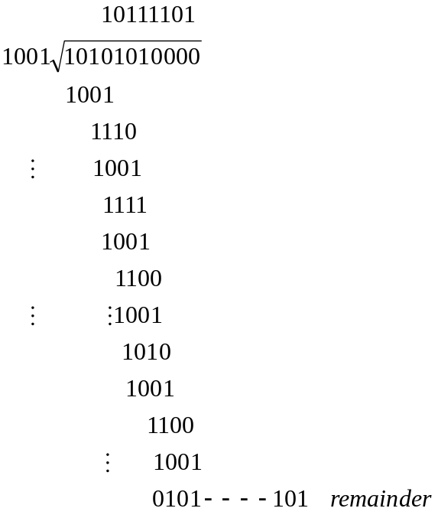
- (a)10101010101
(b) receives 00101010101
the remainder is 10
the receiver knows that an error has occurred when it gets a non-zero remainder

Inverter
Noninverter? 正相器 正向器 buffer 缓冲器（区） 弱的信号 放大，驱动
存储空间

Inverse reverse 逆水行舟

Consider a datagram network with 32-bit host addresses. Assuming that a router has four links, numbering from 0 to 3, the packet can be forwarded to the following link interfaces:

Destination Address Range Link Interface
11100000 00000000 00000000 00000000
through 0
11100000 00111111 11111111 11111111

11100000 01000000 00000000 00000000
through 1
11100000 01000000 11111111 11111111

11100000 01000001 00000000 00000000
through 2
11100001 01111111 11111111 11111111

otherwise 3

a.Provides a forwarding table with four entries, to forward the packets to the correct link interface by the longest prefix matching.
b. What is the appropriate link interface for following destination address?
11001000 10010001 01010001 01010101
11100001 00000000 11000011 00111100
11100001 10000000 00010001 01110111

11001000 10010001 01010001 01010101 3
11100001 01000000 11000011 00111100 1
11100001 10000000 00010001 01110111 2

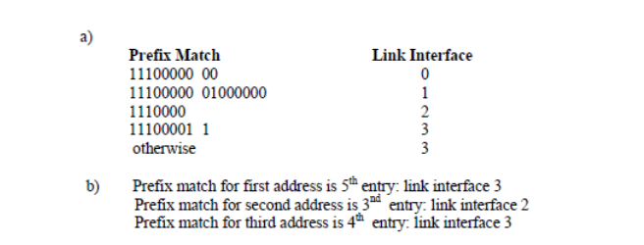

a. Prefix Match Link Link Interface
11100000 00 0
11100000 01000000 1
1110000 2
otherwise 3

b. 与第一个地址匹配的接口是3
与第二个地址匹配的接口是1
与第三个地址匹配的接口是2

